***OBJECT ORIENTED PROGRAMMING ETCS 258***

Faculty name – Ms. Karuna Student name: Syeda Reeha Quasar

Roll No.: 14114802719

Semester: 4th

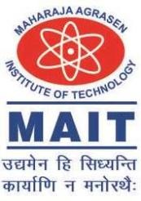

## Maharaja Agrasen Institute of Technology, PSP Area, Sector – 22, Rohini, New Delhi – 11008

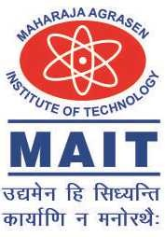

**MAHARAJA AGRASEN INSTITUTE OF TECHNOLOGY VISION**

To nurture young minds in a learning environment of high academic value and imbibe spiritual and ethical values with technological and management competence.

**MISSION**

The Institute shall endeavor to incorporate the following basic missions in the teaching methodology:

**Engineering Hardware – Software Symbiosis**

Practical exercises in all Engineering and Management disciplines shall be carried out by Hardware equipment as well as the related software enabling deeper understanding of basic concepts and encouraging inquisitive nature.

**Life – Long Learning**

The Institute strives to match technological advancements and encourage students to keep updating their knowledge for enhancing their skills and inculcating their habit of continuous learning.

**Liberalization and Globalization**

The Institute endeavors to enhance technical and management skills of students so that they are intellectually capable and competent professionals with Industrial Aptitude to face the challenges of globalization.

**Diversification**

The Engineering, Technology and Management disciplines have diverse fields of studies with different attributes. The aim is to create a synergy of the above attributes by encouraging analytical thinking.

**Digitization of Learning Processes**

The Institute provides seamless opportunities for innovative learning in all Engineering and Management disciplines through digitization of learning processes using analysis, synthesis, simulation, graphics, tutorials and related tools to create a platform for multi- disciplinary approach.

**Entrepreneurship**

The Institute strives to develop potential Engineers and Managers by enhancing their skills and research capabilities so that they become successful entrepreneurs and responsible citizens.



**MAHARAJA AGRASEN INSTITUTE OF TECHNOLOGY**

**COMPUTER SCIENCE & ENGINEERING DEPARTMENT**

**VISION**

To Produce “Critical thinkers of Innovative Technology”

**MISSION**

To provide an excellent learning environment across the computer science discipline to inculcate professional behavior, strong ethical values, innovative research capabilitiesand leadership abilities which enable them to become successful entrepreneurs in this globalized world.

1. To nurture an **excellent learning environment** that helps students to enhance their problem solving skills and to prepare students to be lifelong learners by offering a solid theoretical foundation with applied computing experiences and educating them about their **professional, and ethical responsibilities**.
2. To establish **Industry-Institute Interaction**, making students ready for the industrial environment and be successful in their professional lives.
3. To promote **research activities** in the emerging areas of technology convergence.
4. To build engineers who can look into technical aspects of an engineering solution thereby setting a ground for producing successful **entrepreneur.**